# Airlines Information Maintenance

## Class diagram

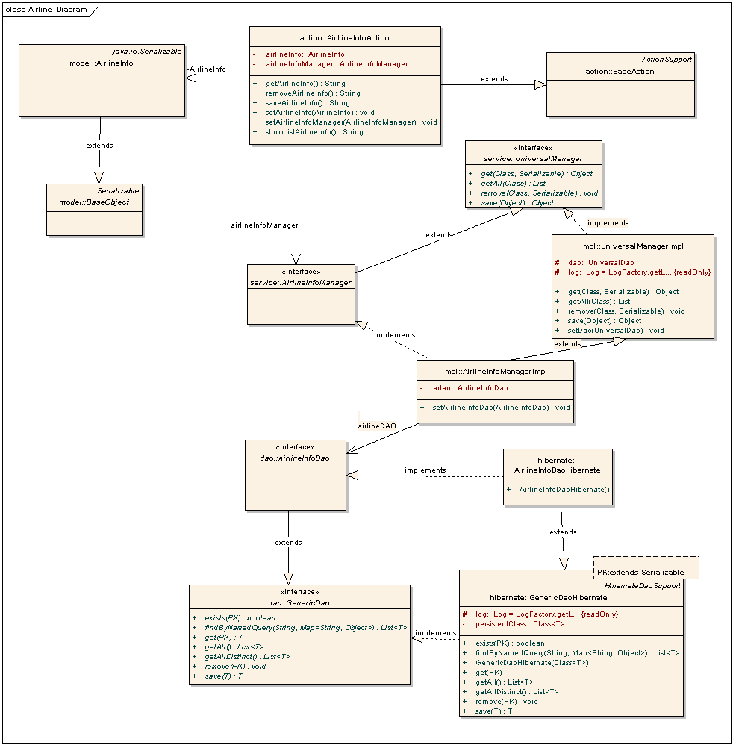

## Sequence Diagram

### List Airlines Information

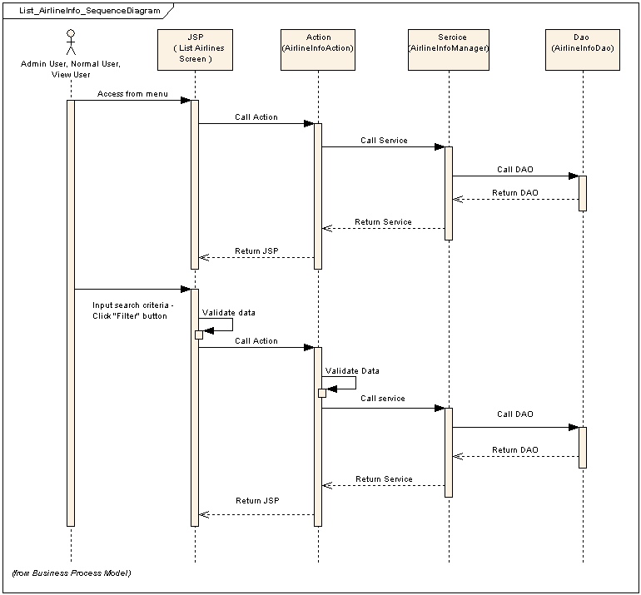

### Add Airline

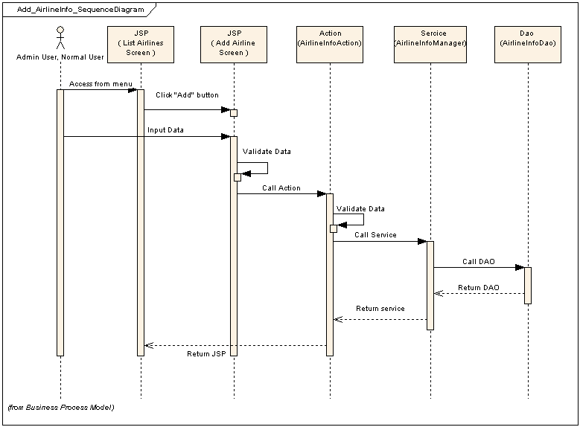

### Update Airline

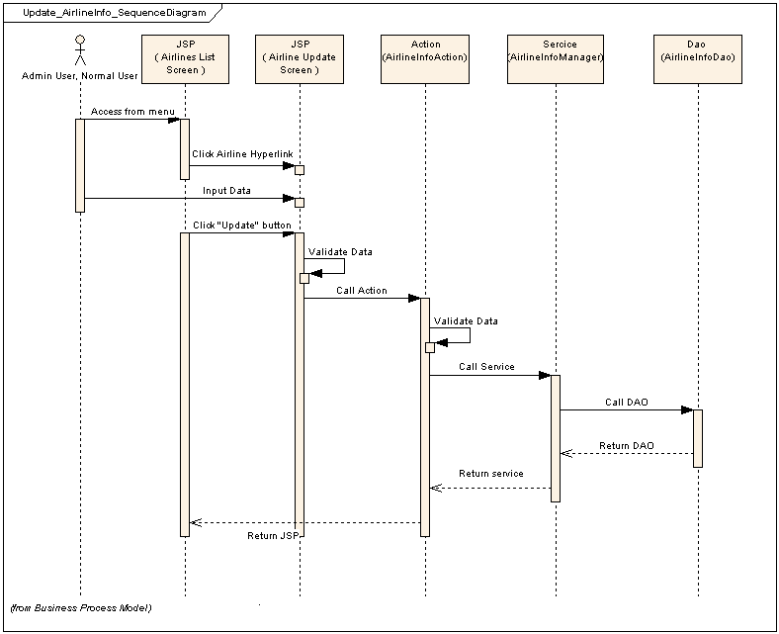

## Screen

### List screen

#### Main flow

|  |  |
| --- | --- |
| **Screen** | Airlines Information Maintenance – List |
| **Description** | Display all airlines information. |
| **Screen Access** | Users click on menu **Configuration -> Airlines Information Maintenance** or choose criteria and click the filter button |

#### User interface

* Filter section

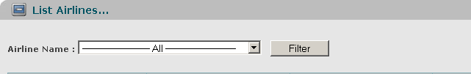

* List data section

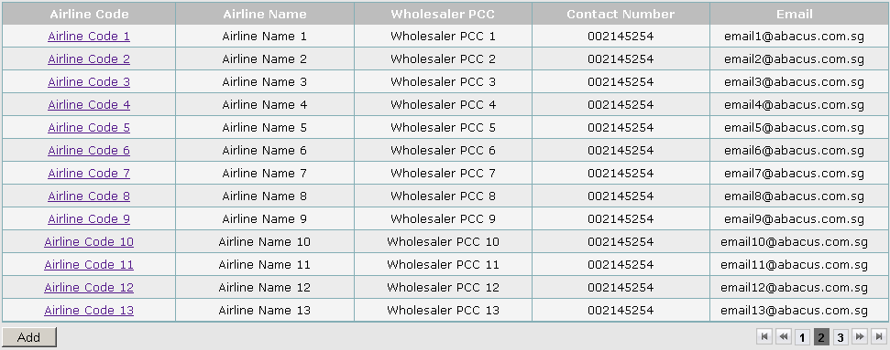

#### Validation Rule/Data mapping

|  |  |  |
| --- | --- | --- |
| **Field** | **Type** | **Description** |
| Airline Name | Dropdown list | * Airline Name – Airline Code * Value default is ‘All’ * Display both name and code but name first, value is code * ordered by AIRLINE.NAME * Mapping to field in DB: AIRLINE_INFO. AIRLINE_CODE |
| Filter | Button | * List data in DB withSoftware High Level Design Document_Sample.doc criteria |
|  |  |  |
| Airline Code | Link | * Airline code   Only display as link if user is Administrator or Normal User   * Mapping to field in DB: AIRLINE_INFO. AIRLINE_CODE |
| Airline Name | Label | * Name of Airline * Mapping to field in DB: AIRLINE_INFO. AIRLINE_NAME |
| Wholesaler PCC | Label | * An agent of Customer * Mapping to field in DB: AIRLINE_INFO. WHOLESALER_PCC |
| Contact Number | Label | * Contact number of airline * Mapping to field in DB: AIRLINE_INFO. CONTACT_NBR |
| Email | Label | * Email * Mapping to field in DB: AIRLINE_INFO. EMAIL |
| Add | Button | * Add button   Only display if user is Administrator or Normal User   * Go to the add screen |

### Add screen

#### Main flow

|  |  |
| --- | --- |
| **Screen** | Airlines Information Maintenance – Add |
| **Description** | Allow Administrator and Normal User Account to add new airlines. |
| **Screen Access** | Users click on the button Add on list airline screen |

#### User interface

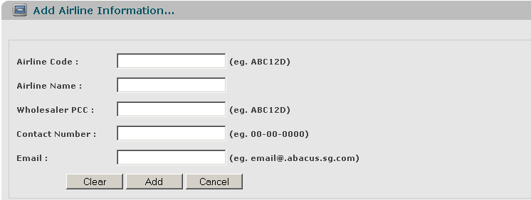

#### Validation Rule/Data mapping

|  |  |  |
| --- | --- | --- |
| **Field** | **Type** | **Description** |
| Airline Code | Textbox | * Airline Name – Airline Code * Must be alpha numeric (5), is mandatory * Insert to field in DB: AIRLINE_INFO. AIRLINE_CODE |
| Airline Name | Textbox | * Name of Airline * Must be String (45), is mandatory * Insert into field in DB: AIRLINE_INFO. AIRLINE_NAME |
| Wholesaler PCC | Textbox | * An agent of Customer * Must be alpha numeric(5) * Insert into field in DB: AIRLINE_INFO. WHOLESALER_PCC |
| Contact Number | Textbox | * Contact number * Must be number (15), is mandatory * Insert into field in DB: AIRLINE_INFO. CONTACT_NBR |
| Email | Textbox | * Email of airline * Must be String (50) with email format eg.vietnv@gmail.com * Insert into field in DB: AIRLINE_INFO. EMAIL |
| Clear | Button | * Clear button * Clear all inputted data |
| Add | Button | * Add button * Insert new record in database |
| Cancel | Button | * Cancel button * Cancel to add new and back to list screen |